ALBERTA ROMANCE WRITERS’ ASSOCIATION
Saturday, June 13, 2020 – 9:00 AM

Meeting ID: 896 5752 0752

Came to order 9:04 am

Board members in attendance: Tammy Lyn Carbol, Bret Cousins,
Diana Cranstoun, Allison Gorner,
Jessica L. Jackson, VI Peace

We have quorum

Non-board member in attendance: Darlene Maynard, Sarah Kades Graham

- REVIEW AGENDA
  - Review with agent – under programing need a speaker for June Thursday GM workshop

- REVIEW MINUTES FROM MAY 9, 2020
Motion by Diana, Seconded by Bret
May 9, 2020 Minutes - Carried

- OLD BUSINESS
  - ARWA Members Only Section – TLC
    - Membership list – updated V email done by Bret
    - Bret will change password end of September and inform members
  - Lockdown Cookbook on Amazon – TLC
    - Amazon money goes into ARWA account every quarter Alison as treasurer to check on account to see what is transferred into ARWA’s bank and report to president and board at meetings
    - Cookbook was on Bookbub free for electronic devices now the cookbook is live on Amazon for both print and eBook download.
  - Treasures Update – Jessica/Vi
    - Treasures 2020 is live $13.10 cookbook softcover $1.00 eBook
      - Book purchase links to 2018 Treasures – V to contact Amazon and try to fix.
  - Diana Has the ARWA Banner
    - Darlene mentioned the ARWA banner would be nice to use for Zoom video background. Allison posted it in comments for those who want to use it for Zoom workshops.

- NEW BUSINESS
  - Meeting minutes on members section? – TLC
    - Post Board Minutes on Facebook
    - For transparency minutes will now be posted online
    - Sarah wants Board to use minutes as an encouragement for members to read and as a Board recruitment tool to see what happens in Board meetings.
    - Bret will look at putting together a folder behind the first page, and adding security. He’ll put the board minutes and videos on a secret page and consult with Dave to ensure it goes up without a privacy risk.
Motion by Bret, Seconded by Jessica
Board minutes added to private members’ area on Facebook along with Zoom links - Carried
  - Due to Zoom meetings - TLC
    - Will we be year round? May 31
    - Would that change our year end? Jan-Dec or Sept-June? No will remain May 31st. Tax deadline – remains the same
  - AGM Update -ALL
    - Proxy?
      - Will be updated and forwarded to Diana to post to the group,
        - Wording: Here is a copy of the proxy for the AGM If you can’t make the meeting, please send in your proxy.
        - Scan or take a picture and email to secretary at v@vipeace.ca
        - There is an option to put a ‘zoom vote tracker’ in place for AGM – Bret will look into it.
    - Who will be Election Chair?
      - Jessica L. Jackson is election chair
    - Anyone for Secretary?
      - It will be posted that without a secretary we don’t exist, and brought forward during today’s workshops that we require a secretary. Note: V will continue if no one is found.
    - Anyone for Program Chair?
      - No one has stepped forward as yet. It will be brought forward during today’s workshops that we require a secretary Note: Diana will continue if no one is found.
  - WWC
    - Presentations – Bret
      - Bret will be putting up a reminder to be posted with the ARWA programs.
      - Bret hasn’t seen the WWC presenter sign up form. Sarah said there are 5 links to bulletins and forms on website.
      - TLC will send in her panel form title, blurb, and video link for WWC conference.
    - Click and answer guidelines for all presenter forms to become a presenter.

    - Merchant’s Room – Bret
      - Sarah said Merchant’s room plan is to have a shared author page on the WWC website with a list of books and link to purchase. Only the book title and author will be listed with a link to purchase, no book covers or promotion.
      - Bret feels this is not conductive for sales.
      - Sarah mentioned Gary is the only person who will be setting up the WWC Store on the website with membership home merchant room to sell over 400 books on the web. See post Board meeting discussion…

  - Presenter required for ARWA GM Thursday June 25th 7 -9
    - Sarah will present a WWC Coles notes
      - She will send Diana a blurb to post
      - Allison will make the graphic and post it
    - Per below discussion – Allison will co-present with Sarah. She will do a video on How to Make Video for WWC presenters.

- NEXT BOARD MEETING – July 11, 2020 at 8:45 log on meeting at 9AM.

Meeting adjourned at 10:13 AM
Zoom host was passed on to Bret for recording workshop
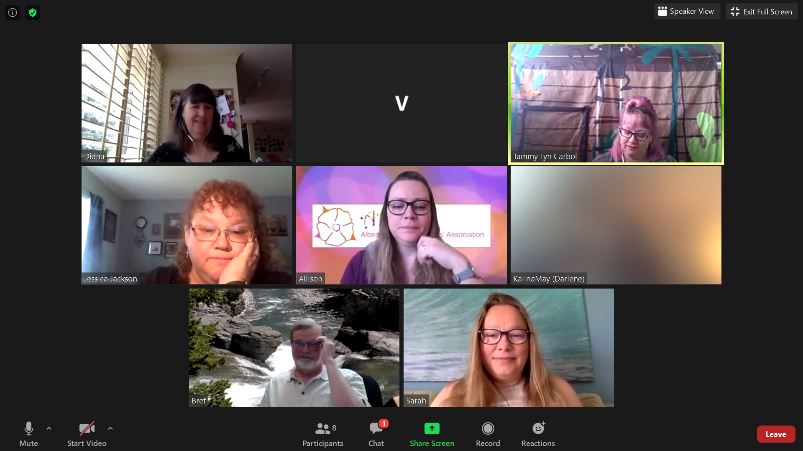

Post Board WWC Discussion

The ARWA plan is to have an Author book selling webpage linked and posted on the WWC website. Link members’ books to purchase on Amazon or their author website. This will be shared on WWC author book table sale page.
The goal is ARWA will set a precedent and post page with genre, author purchase page it can be thrown into the list cover, title, link to buy, blurb, and it will be posted on the page for both ARWA and WWC to promote.

Presenters:
Deadline July 1st for presenters. Late entries will be given space to present at Randy’s discretion.
There are some ARWA Presentations already done and on ARWA’s YouTube. Although they are not live, can these be presented as a prerecord zoom workshop with a pre-workshop and post-workshop discussion for and moderation for WWC?
Sarah cautioned: Prerecoreded Zoom meeting are boring. For WWC it should be a live presentation. It engages the watchers and harnesses the video medium.
For WWC there will be a schedule for all workshops to be live. YouTube channel WWC link sounds great, but how many participants will we get is something we will find out when presentations are presented. To draw participants there needs to be a wow factor.

Sarah:
WWC wants to harness the mediums available.
Dave Sweet – Might go live in the morgue, things like this to have fun with and effort drawing the audience.
An ARWA notice to presenters to jazz up their presentation videos and how to present would be great. Perhaps a video on how to make a video. Allison will join Sarah on Thursday June GM and present video assistance
Bret got the impression that they want to use their own WWC Zoom and will list a schedule for 50-minute sessions. The thought is to fill the weekend with ARWA Zoom and ARWA presentations that will be awesome and promote ARWA and diversity of the group.
Diana requested a blurb on this to post.

