MINUTES
ALBERTA ROMANCE WRITERS’ ASSOCIATION
Board Meeting
Saturday, June 12, 2021

Zoom Meeting: 81636163652

In Attendance: Tammy-Lyn Carbol, Bret Cousins, Allison Gorner, Liz Grotkowski, Darlene Maynard, Diana Cranstoun, Jessica L. Jackson, Cassandra Arnold

- REVIEW AGENDA – Allison added 2 items

- REVIEW MINUTES FROM Saturday, May 8, 2021 – Cassandra asked that her apologies for the May meeting be added. Motion to accept the minutes: Allison, 2nd Liz, carried.

- NEW BUSINESS
- Need to have 5 year plan to submit at AGM – Cassandra recalled that we did make a new 3 year plan last year. Tammy found this and we amended it to be presented to the members this year:
- 2021-22 35th anniversary Book in a Year launch and party at WWC
- 22-23 mini retreat
- 23-24 Editor Workshop eg Adrienne Kerr

Motion to accept the plan: Moved Diana, 2nd Bret, carried

- Presentation on how hard it was get new members during pandemic – Diana shared her experience with Toastmasters, saying that most groups struggled to get new members, as we have as well, and that one group had set a very clear goal of 2 speakers per meeting, with a system for mentoring new speakers and encouraging then to follow the method to success. This could be adapted for us as well.

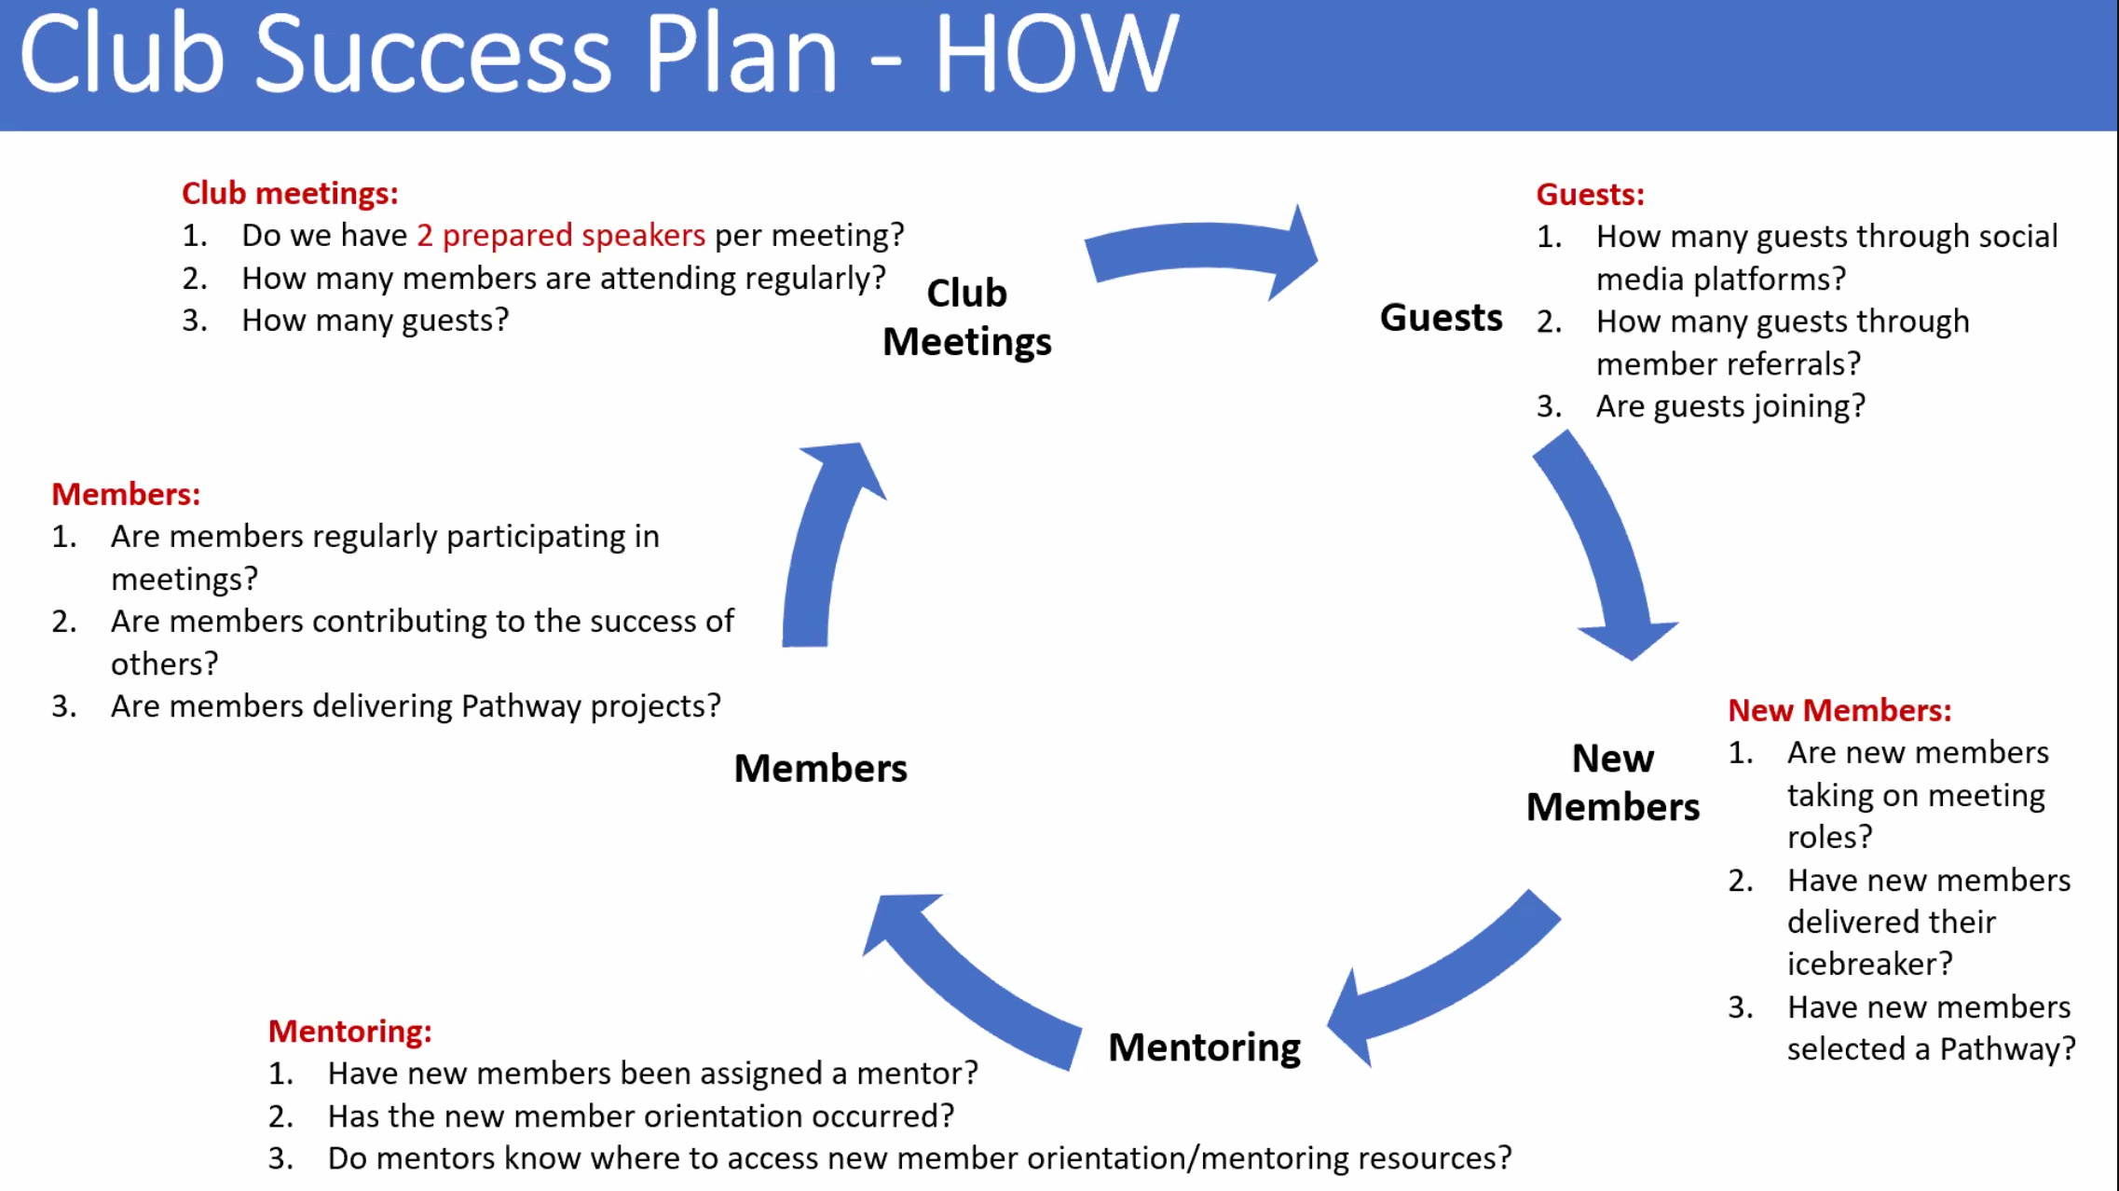
DO NOT SHARE THIS GRAPHIC PLEASE.

- 35th anniversary Swag Allison has been researching options for mugs, buttons, and stickers. The prices for a bulk order look promising eg mugs about $4.30, so we could sell them for a profit. She will send out a list with more details for us to consider. We could also add T-shirts, and we can give the graphic to members who would like to make their own products as well.

- OLD BUSINESS
- PayPal Name Change Allison has made the changes. It is now in Jessica’s name, with Darlene and Allison as phone contacts. It is currently set up with the treasurer email.
- Goodreads account is up Tammy expressed out thanks to Allison for all this work for ARWA. the account is now up with several books listed. The new social media member will update after the AGM. We will set up a new social media email that can be the same across all the accounts.
- Election Chair – Jessica Jackson agreed to do this. She reviewed the previous agenda for an AGM, will send this to Tammy to finalize. We decided to add a draw for a $50 Chapters gift card, which can be won only by those attending the AGM.
- AGM Proxies were sent out on time. A question came in about the proposed policy change, so these will need to be discussed on the night, and an amendment proposed if necessary.
- Social media board member – ask at meeting and AGM
- 35th Anniversary graphic looks fabulous! Thanks Allison
- Email consolidation: Allison has closed the following:
- ARWA_president@outlook.com
- ARWA_general@outlook.com

The incoming Board can consolidate the Treasurer email across all our accounts.

- BOARD HANDOVER MEETING – We decided we do not need a specific Board handover meeting, as Allison and Darlene are already talking, likewise Tammy and Bret, and Casssandra will liaise with Del.

- Also discussed but not on the agenda:
Allison proposed that the Treasurer should have access to our Amazon account, and give reports on sales from time to time

Meeting closed at 10.10am

Next meeting: 9am on Saturday July 10

