MINUTES
ALBERTA ROMANCE WRITERS’ ASSOCIATION
General Meeting and Workshop
Saturday, April 10, 2021 at 10.30 AM

Zoom Meeting ID: 897 1924 6835

Attendees:

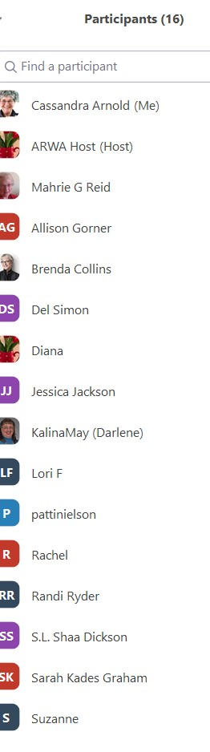

Diana, the Vice President, was the Chair as Tammy had an appointment to attend.
She welcomed us all.

Announcements:

- Darlene continues to host co-working sessions by Zoom at 7pm Monday evenings. There are 3 regular attendees and you are all very welcome. Email Darlene at kalinamay@gmail.com to be added to the Zoom Invite list.

- It is ARWA’s 35th anniversary on May 20 2022, so the incoming Board is looking for ideas for how to celebrate this. Current ideas include a party at WWC 2020, a private members party around the actual date, seeking a special speaker for the occasion.

- Our AGM is in June. Tammy asked for a volunteer to the the AGM Chair, who would be required to run that section of the meeting, introduce candidates and tally the voting. Let her know if you are interested in helping out. Full instructions provided!

- Board members needed:
  - President
  - Vice President
  - Treasurer
  - Secretary
  - Website Manager
  - new position of Social Media Manager
  - new position of Assistant Secretary if Cassandra remains as Secretary (because of likely post-Covid travel)

Our next newsletter will include short versions of the duties of these positions and the likely time commitment required. Mahrie suggested this is also sent out as a stand-alone email. Bret will add to the website.

There were no good news items this month.

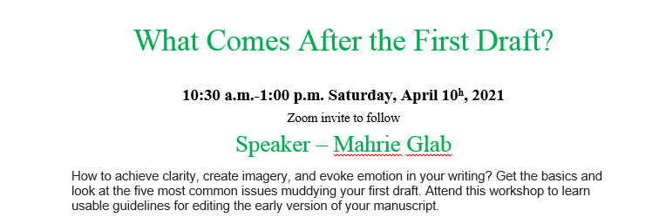
WORKSHOP

Mahrie provided us with a handout to download for the workshop:

Topics & URLS from the presentation, April 10, 2021

- Content Review - https://uninspiredwriters.com/2020/05/31/editing-a-scene-chapter-step-by-step/

- The English Language – if you want to know more
- https://wordcounter.io/blog/how-many-words-does-the-average-person-know

- The Foundation of Editing.
Nouns
Verbs
https://www.basic-english-grammar.com/a-list-of-helping-verbs.html/ and https://www.englishclub.com/grammar/verbs-classification-helping.htm

- Sentence Structure – sequence & danglers

- The History of Words on the Page.

- Putting it all to work- Editing software
https://becomeawritertoday.com/book-editing-software

- The five key areas most commonly muddying our writing.
1) telling instead of showing,
2) passive instead of active structures
3) too many prepositional phrases
4) overuse of perception words (felt, saw, heard...)
5) a proliferation of adverbs - the lazy ly and other modifiers

- Choose Active over Passive
https://www.mahriegreid.com/2014/03/make-your-writing-active.html

- How to change to telling to showing – one quick tip
https://www.mahriegreid.com/2021/04/three-steps-to-move-from-telling.html

- PPCs and what to do about them
https://www.mahriegreid.com/2014/03/write-stronger-eliminate-ppcs.html

An exercise with preposition phrases.

A ping sounded from the kitchen next door to the study in the house she’d bought in a town to the north of the road to Hartford. (7 PPC’s)
- That’s seven of the darn things.
- Tip: Use your ‘find’ function [find ‘of’ and click ‘find whole words’
- First, count each preposition.
- Make a list of the ones you use most.

- Adverbs – to use or not to use?
“Ly words almost always catch the author in the act of explaining dialogue – smuggling emotions into speaker attributions that belong in the dialogue itself.”
Self Editing for Fiction Writers by Renni Browne and Dave King. Pg 51

https://www.mahriegreid.com/2014/03/the-deadly-ly-stronger-writing-6.html

- Perception verbs:
- saw, heard, thought, and smelled are unnecessary.
  - Also: felt, wondered, guessed, decided, heard, saw, and maybe more
- https://www.mahriegreid.com/2014/03/write-stronger-perceptions-in-point-of.html

- mahrie.reid.writer@gmail.com
- https://www.MahrieGReid.com
- https://www.facebook.com/MahrieGReid
- https://twitter.com/MahrieGReid

Mahrie very kindly offered to do a Blue Pencil of the edit of the first 2-3 pages/scene of members’ works. Send them to her in an email with the subject line Blue Pencil Edit

Meeting closed at 12.30 pm

