Brain Gym
I learned this at the Chinook Learning Center about 12 or so years ago when I attended a workshop with my sister Trish under the Calgary School Board. I attended the CSB workshops for about 8 years. Interesting topics were offered, including Brain Gym. (Note - some of you will remember my sister from years ago when she was a writer and a member of ARWA)
Your brain crosses over naturally. However, to help your brain to keep strong, let’s practice – Brain Gym. Seriously, we keep our bodies healthy with exercise, fresh air and good food… so why not treat our brain to the good things in life. Right?

Right Brain Vs. Left Brain
You are probably already aware of some of these distinctions between the left brain and right brain: Here’s a reminder.

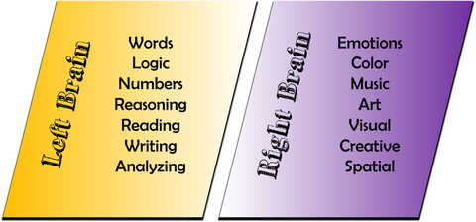

When I first started Brain Gym years ago, I found that I was more energized, mentally, physically & spiritually. It was amazing. I couldn’t believe it myself. But it works.
I brought it to work with me to teach the youth. Of course some of the kids thought I was losing it. Others took me seriously and tried it and found a difference in their energy level. So, success with the kids that tried it. Can’t help everyone.
When I started taking treatments last year, I stopped doing Brain Gym. But it didn’t leave me. The funny thing about brain gym, in my experience, is that even if you don’t do it for awhile… all you need to do is think about it. It was remarkable that just doing it in my mind while laying down, I felt better.
I’m a writer, not a scientist, so whether it’s true or not, that you can just think about it and it will work, I can’t answer that. But it seamed to work for me. Mind you, it may be because I’ve been doing brain gym for years. So maybe my brain is now accustomed to doing it and will allow me to just think of it when I’m not feeling well. Hope that makes sense to you.

Lets get started.

Brain Gym
Crossing over from Left to Right & Right to Left
To stimulate your brain for - memory, writing, and being creative.

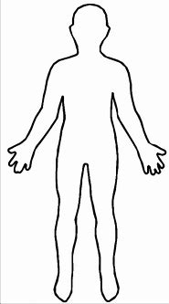
- Ear
- Neck

- Shoulder to shoulder

- Elbow to elbow

- Waist to waist

- Hip to hip

- Thigh to thigh

- Knee to knee

- Calf to calf

- Toe to toe

Part 2. – from the back reach Left to Right starting from the top of your head (your ears) then follow through to your toes
Part 3 – Lay down on the floor and repeat front of body.to your waist then use your legs to cross over your knees, calves and toes.
Part 4 – turn over on your stomach and repeat part 3.
Part 5 – Make a game out of it. Think of other ways to cross over. Use your right brain to be creative. Example – right elbow to left knee and visa versa.

The brain is a wonderful thing. I encourage everyone to at least try it for a couple weeks, then please let me know how you feel.
NOTE – There’s more information on Left & Right brain on the web. For fun check it out. Just type in – Brain Gym – and see all sorts of info.
Also check out https://chinooklearningservices.com (It used to be called Chinook Learning Centre.

Happy exercising everyone.

