MINUTES of ARWA Thursday evening Meeting March 24, 2022

Zoom Meeting ID: 849 0590 0424
Opened 7.03pm, closed 8.30pm
Announcements:
- BIAY should be sent to the editor next week
- Deadline for submission to Treasures along the Fenceline is April 1^{st.} We don’t yet have enough stories, might have to extend the deadline.
- Bret introduced our speaker Darlene

Presentation:

“Writing Romantic Fiction”, by Barbara Samuel, A Review
by

Darlene Maynard

Darlene provided an excellent overview of this book, and how to write a romance. She gave us a worksheet in addition to slides to be distributed to all members.

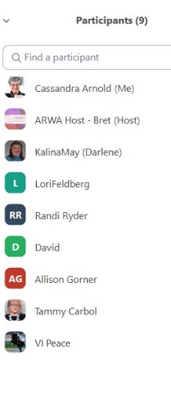
Participants:

