ARWA BOARD MEETING AGENDA
For January 20, 2026
7:00 pm MT

Join Zoom Meeting
https://us02web.zoom.us/j/86757309227?pwd=fUQU2LQ0HaFqh0tBf5aOARua9fe6gN.1

Meeting Start: 7:02 PM (MST)

In Attendance: Deb Draper, VI Peace, Darlene Maynard, Jessica L. Jackson, Shaa Dickson, Randi Ryder, and Rachel Baird

Apologies: Diana Cranstoun

- Call to Order

- Changes/additions to the agenda
  - Added: Digital Rights Management and Spam / AI E-mail

- Adjustment to Minutes of October 21 Board meeting: Deb made a motion to continue to display a membership contact list outside of the registrar; however, it wasn’t clear who seconded the motion. Since the seconder is still unknown, we need to make the motion again and vote.
  - Deb made a motion to continue to display a membership contact list outside of the registrar.
    - Randy seconded this motion.
    - 4 in favor. 2 abstained.
    - The motion was passed.

- Approval of minutes of the previous Board meeting on November 18, 2025.
  - Deb made a motion to accept the November 2025 Board meeting minutes.
    - Darlene seconded this motion.
    - All were in favor of accepting this motion.
    - The November 2025 Board meeting minutes were approved.

- Treasurer’s report (V)

- ARWA website (Rachel): redesign, administration, book area, other
  - Rachel gave an update on the recent aesthetic and functional changes to the website (themes/pictures, etc.)
    - If Board members have recommended changes to photos on the website, please send Rachel an email with the recommended photos (must be royalty-free and good quality).
  - Rachel raised a concern about our only Administrator account being a non-ARWA member.
    - It was agreed that we should have a backup Administrator account for the Board.
  - Rachel raised a concern about the Administrator of our website being both a non-ARWA member and an unofficial volunteer.
    - Certain Administrator tasks must be completed annually to ensure compliance with security requirements, new regulations, and optimal performance. So, in addition to an “emergency” contact as an Administrator, we need someone who is managing our website at this level. Ideally, an ARWA member, but those skills have been historically hard to find.
    - It was agreed that we would further discuss whether David would like to come on Board as an official volunteer, which would include signing a form, or if he would prefer a form of compensation. Or if we need to explore other options for handling the Administrative side of the website.
  - Rachel will add Treasures 2025 to the Book Room.
  - Social Media - The Board discussed whether we should remove old members from our private Facebook group. There were mixed opinions on this.
    - The Board agreed that we need to remove old Administrators from the Facebook group and add current Board members as Administrators.
      - Tammy will add current Board members as Administrators.

- Membership: New member? (V)
  - No new members. 30 members altogether (27 paid).

- Programs: April 28 Setting workshop speaker still needed
  - We will send out a specific request in the newsletter.

- Treasures along the Fenceline:
    - Amazon DRM (Digital Rights Management) – see attached letter at the bottom.
    - General overview: If we check this box, it will help to protect our books from piracy, but it will limit e-book readers to Kindle devices.
      - The Board agreed that we should check the box for Digital Rights Management for Treasures.
    - Volunteers – for the magazine, for the contest
      - We haven’t had any volunteers step forward.

- Spam / AI E-mail
  - A recent spam e-mail sent to the ARWA e-mail address included information about one of our members and their books. The Board discussed the recent uptick in these types of spam e-mails and how we can recognize them and protect our members.
    - Rachel will include a notice/article warning our members about recent AI/spam e-mail targeting writers/authors in the ARWA newsletter.

- Next Board Meeting February 17, 2026, at 7:00 pm MST

Meeting adjourned. 7:44 PM

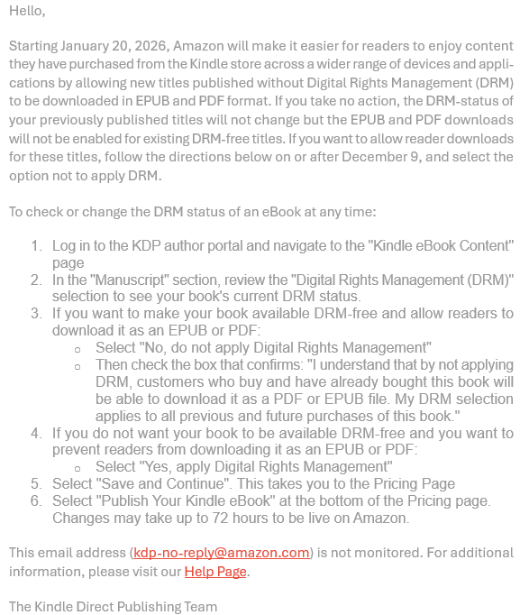

ALBERTA ROMANCE WRITERS’ ASSOCIATION
General Meeting. January 26/2026
Held on Zoom

In Attendance: Darlene Maynard, Shaa Dickson, Suzanne Stengl, Randi Ryder, Lori Feldberg, Kirsten Clark, Deb Draper, Maureen Haseloh, VI Peace, Diana Cranstoun, Jessica L Jackson, Gail Williams.

Meeting Started, 6:59 MST.

President’s Remarks:
- We are still looking for someone to present the Setting Workshop in May
- Rachel has revamped the website. Deb asked members to have a look at it and send Rachel comments.
- We are still looking for a Website Administrator.
- We are going to leave the Facebook Page as is – open to current members and ‘alumni’.
- We are looking for beta readers for Treasures – contact Rachel or Deb.
- Reminder, we are holding a writing contest this year.
- Del put out a request for members to sit at the ARWA table during WWC. No one has volunteered, so ARWA will not have a table at WWC this year.

Jessica L. Jackson then gave a great presentation titled "Characters Alive!"

Meeting ended approximately 8:25 MST.

